# Demand Curve Formula

Demand is the amount of goods consumers are willing to buy.

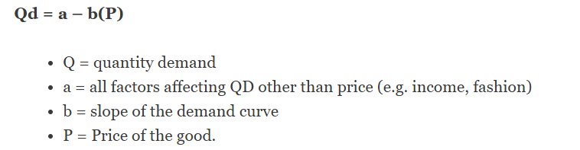

Demand depends on several factors, such as price, perceived quality, advertising, income, confidence of consumers and change in taste.

